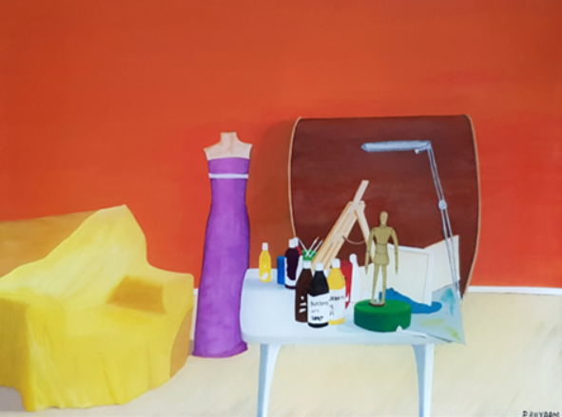
Titel: An artist home - Mål: H 60 cm x L 80 cm - Matr. Akryl og resin på lærred

English below
Udstilling på Humlebæks bibliotek
Det var jo meningen, at jeg skulle udstille på Humlebæks bibliotek, i den tidligere byråds sal, i januar 2021, men på grund af Corona blev udstillingen aflyst.
Heldigvis har jeg fået en ny udstillingsdato. Fernisering er den 20. november og sidste udstillings dag er den 10. december 2021.
Sæt kryds i kalenderen hvis du har tid og lyst til at deltage. Lige så snart indbydelsen er trykt sender jeg den til dig.
Om maleriet
Faktisk startede jeg på dette maleri for omkring 15 år siden, men jeg kunne ikke rigtig få det til at blive som jeg gerne ville have, det skulle se ud. Derfor besluttede jeg at stoppe med at male mere på det. Jeg stillede maleriet til side og tænkte, jeg ville male på det igen, når jeg var parat til det.
At der skulle gå 15 år inden jeg begyndte at male på det igen, havde jeg nu ikke forventet.

Grunden til at jeg kom i tanke om maleriet igen, var nok fordi, det værelse som jeg havde indrettet til atelier blev fyldt til bristepunktet med 3D printer og alt hvad der hører sig til. Jeg ville jo også kreere skulpturer, og hvis det skulle kunne lade sig gøre, så måtte jeg tage staffelier og andet malergrej ud af værelset og fylde det med 3D grej, så nu er jeg igen henvist til at være i stuen og på terrassen når jeg skal male, men i det mindste har jeg fået opfyldt mit ønske om at kunne kreere skulpturer, fra idé til den står færdigt.
An artist home
Motivet er fra min stue, som den så ud dengang.
Jeg havde ikke noget lokale, jeg kunne bruge som atelier, så derfor var jeg henvist til, at tage noget af stuen i brug, hvor kunne jeg udfolde mine kunstneriske evner.
Selvom jeg brugte en del tid hver dag, med at samle malergrejet samme, så det fyldet så lidt som muligt, kunne det ikke undgås, at det så rodet ud i stuen.
Engang hvor vi skulle have gæster tænkte jeg, at jeg ville pakke det hele sammen og væk fra stuen, så der var helt pænt og ryddeligt når de kom på besøg.( jeg synes også de skulle opleve stuen uden malegrej, staffeli osv.)

Jeg blev godt nok overrasket over deres reaktion, da de kom ind i stuen og så, at den var fin og flot ryddet.

- Øh hvor er dit malerudstyr? Du er vel ikke stoppet med at male?
- Nej nej svarede jeg, jeg har bare ryddet det hele væk, så der kunne være fint til I kommer.
- Det behøver du ikke, vi synes det er inspirerende at være her mellem dit kunstudstyr og det er skønt, at kunne mærke den passion du har for din kunst.

Den sidste del havde de ret i. Jeg har stor passion for det kunst jeg fremstiller, og det vigtigste for mig er, at jeg har mulighed for at kreere mine kunstværker, uanset om jeg har et atelier til rådelighed eller ej.
Denne episode var grunden til, at jeg begyndte at kaste mig over, at male min egen stue, som den så ud dengang med malergrejet, hvilket stuen også er fyldt med i dag, skrivende stund.
Det jeg gerne ville have maleriet skulle udstråle var passion for det man brænder for, også selvom rammerne ikke er perfekte.
Nu 15 år efter, har jeg malet maleriet færdigt, og jeg er godt tilfreds med slutresultatet, for det er blevet nøjagtigt som jeg ville have det dengang.

Global rangliste for kunstner
I 2017 opdagede jeg, at jeg som kunstner, var blevet optaget hos Artfacts, som bekendt ranglister kunstner fra hele verden, hvilket jeg blev stolt over. I 2017 havde jeg plads nummer 115.604 ud af 500.000 kunstner og i dag er jeg rykket frem til plads nummer 67.303.
Jeg håber du får en dejlig dag
Du kan klikke på linket, så kommer du ind på Artfacts side
https://artfacts.net/artist/pia-buxbom/558383/trends

Kærlig hilsen
Pia
English
Exhibition at Humlebæk's library
I was supposed to exhibit at Humlebæk's library, in the former city council hall, in January 2021, but due to Corona, the exhibition was canceled.
Luckily I got a new show date. The opening is on November 20 and the last day of the exhibition is December 10, 2021.
Tick ​​the calendar if you have the time and desire to participate. As soon as the invitation is printed, I will send it to you.

About the painting
Actually, I started on this painting about 15 years ago, but I could not really make it look the way I wanted it to. Therefore, I decided to stop painting more on it. I set the painting aside and thought I would paint on it again when I was ready for it.
That it would take 15 years before I started painting on it again, I had now not expected.
The reason I came up with the painting again was probably because the room I had arranged for the studio was filled to the brim with a 3D printer and everything that belongs to it. I also wanted to create sculptures, and if it was to be possible, I would have to take easels and other painting equipment out of the room and fill it with 3D equipment, so now I am again referred to be in the living room and on the terrace when I must paint, but at least I have fulfilled my desire to be able to create sculptures, from idea to completion.

An artist home
The motif is from my living room as it looked at the time.
I did not have any room I could use as a studio, so therefore I was referred to take some of the living room into use, where I could unfold my artistic abilities.
Although I spent some time each day assembling the painting gear the same so that it filled as little as possible, it could not be avoided that it looked cluttered in the living room.
Once where we were going to have guests, I thought I would pack it all together and away from the living room, so it was quite neat and tidy when they came to visit. (I also think they should experience the living room without painting, easel, etc.)
I was probably surprised by their reaction when they came into the living room and saw that it was nice and nicely tidy.
- Uh, where's your painting equipment? You have not stopped painting, have you?
- No no I answered, I just cleared it all away so it could be fine until you come.
- You do not have to, we think it is inspiring to be here between your art equipment
and it is great to be able to feel the passion you have for your art.

The last part they were right in. I have a great passion for the art I produce, and the most important thing for me is that I have the opportunity to create my works of art, whether I have a studio available or not.
This episode was the reason why I started throwing myself into painting my own living room, as it looked then with the painting equipment, which the living room is also filled with today.
What I wanted the painting to radiate was passion for what one is passionate about, even if the setting is not perfect.
Now, 15 years later, I have finished painting the painting, and I am well satisfied with the end result, because it has turned out exactly as I wanted it to then.
Global rankings for artist
In 2017, I discovered that I, as an artist, had been admitted to Artfacts, as you know, ranks artists from around the world, which I was proud of. In 2017 I had place number 115,604 out of 500,000 artists and today I have moved up to place number 67,303.
You can click on the link and you will enter the Artfacts page
https://artfacts.net/artist/pia-buxbom/558383/trends
Love
Pia

